Thank you for entering the
Withernsea 10K
UKA licence number 30956
and Fun Run
on July 5 2026
hosted by
Withernsea Harriers
Please familiarise yourself with the following race day information

Fun Run start time 09:15
10K start time 10:00
Both start at Pier Towers, Central Promenade
Number collection on Central Promenade

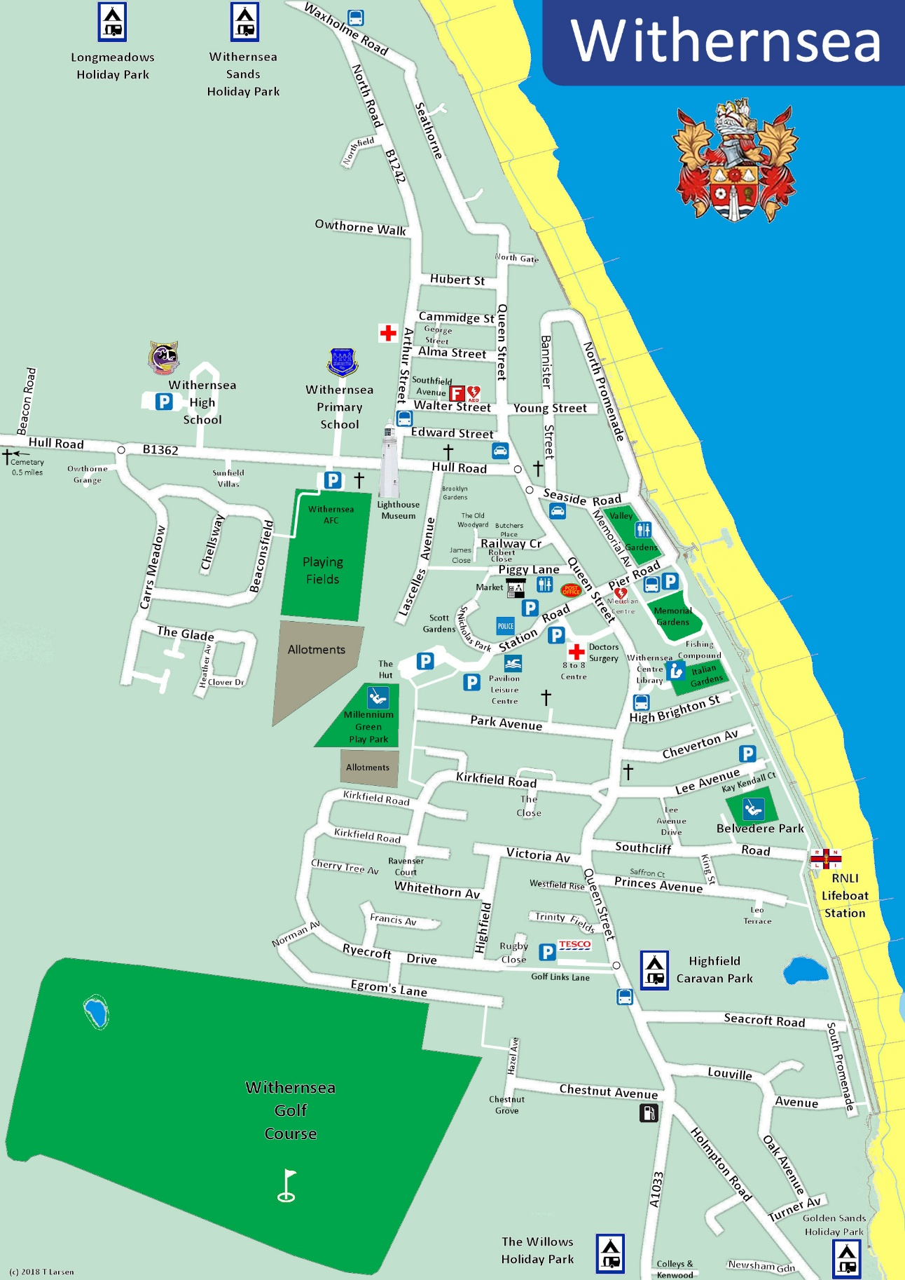
Race HQ
Useful post codes
Race HQ ….. HU19 2JS
Station Rd car park … HU19 2QA ….. Public toilets
Lee Avenue Car Park … HU19 2HQ

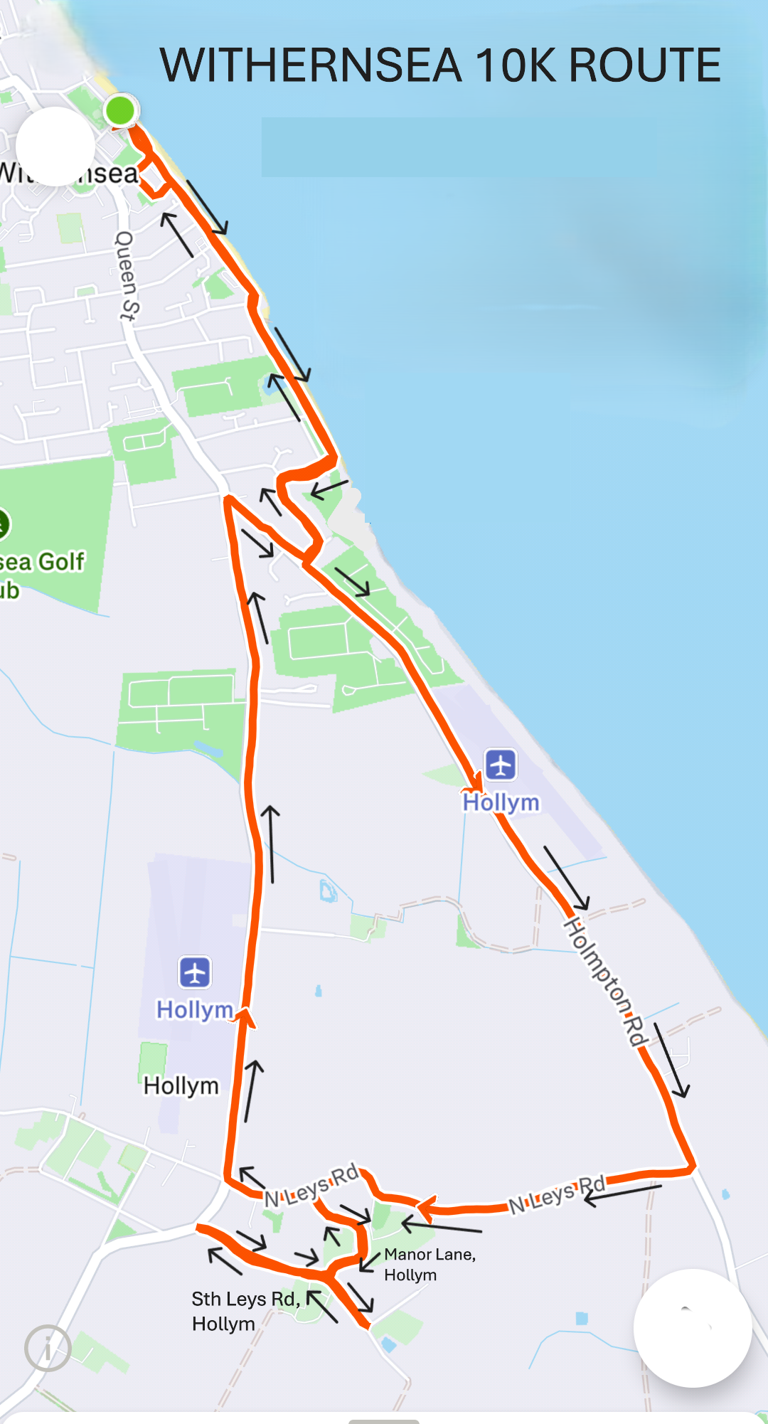
Getting there:
by car
Follow the A1033 from Hull. This is the longest and slowest route but with less twists and turns. Alternative roads are the B1242 and B1362.
On arriving there are a number of parking options. We recommend Station Road car park, postcode HU19 2QA or Lee Avenue HU19 2HQ. These are both free for the day and are only about 5 minutes walk away. Please do not use Aldi car park. It is for customer use only and has a strict time limit and penalty charges.
The car park on Pier Road is nearest to the start/finish but has a £4 charge for the day. There is also a car boot sale on that day which may limit the number of spaces.
by bus
The number 75 bus leaves Hull interchange at 08:10 and arrives at Memorial Avenue, Withernsea at 09:20. From there it is a 2 minute walk to number collection on the promenade. This is the only bus that arrives in Withernsea in time for the start of either run.

Race HQ
This will be adjacent to the coastguard station behind Castle Cafe (see map). It will be open from around 08:00 for number collection and fun run entries.
Entries for the fun run will be available on the morning, cash only please. Sorry but there will be no entries on the day for the 10k race.
Baggage storage will be available in the new blue beach hut adjacent to the coastguard station.

Race Number and Timing Chip
Numbers are to be collected on the day from around 8:00 from the gazebo adjacent to the new beach huts. Please go to the desk with your surname initial. Your race number must be worn on the front of your vest/shirt and must not be folded or mutilated in any way (UKA rules). Safety pins will be available at the desk.
After collection, please fill in the details on the reverse side of your number. This is important in case of an emergency.
Your timing chip will be attached to the reverse side of the number. Please do not remove it or your time will not be recorded.
Toilets
Public toilets are available on Central Promenade situated under the memorial clock.
If you are using Station Road car park you may wish to consider the alternative toilets on Piggy Lane, almost opposite The Commercial public house.

First Aid
First Aid will be provided by East Riding Ambulance Service (ERAS).
There will be a first aid post at the start / finish area and near to the halfway point. There will also be a responder car following the race. If you require assistance for yourself or a fellow competitor, please inform your nearest marshal so that they can get assistance to you as soon as possible.

Safety
Do not run if you are unwell or do not feel fit enough to complete the course.
If you feel unwell during the race, walk or stop. We have marshals all around the course who are there to assist you.
Both the fun run and the 10k race are out and back along the same stretch of the promenade.
Please remember that the promenade is not closed to the public and is used by pedestrians, dog walkers and is also a cycle path. We have marshals to warn people of the race but you do not have right of way over any other users. Please be cautious, particularly at the start of the race whilst everyone is still close together, and near children and dogs as their behaviour may be unpredictable. Please be respectful of others’ rights of way. Also please avoid spitting whilst on the promenade.
Both runs pass the commercial fishing boat compound and the lifeboat station. Leisure boats also launch from the lifeboat slipway. We do not have right of way over any of these. Marshals will be able to liaise with the boat owners to minimise any disruption but if the lifeboat is launching this must take priority and if the marshal tells you to wait then you must wait. Similarly, the start is on the road outside the coastguard station. If there is an emergency before the race then the start time may be delayed to allow vehicle access.
In hot or humid weather, we are sometimes visited by swarms of black bugs. These are completely harmless and can disappear as quickly as they arrive but you may wish to consider sunglasses to keep them out of your eyes. They are attracted to bright yellows and oranges so if you usually run in those colours consider bringing a darker colour as a backup.
Fun Run
The fun run is entirely on the seafront. It is straight out and back along with a turn around at the south end of the promenade. As runners will be running in both directions it is essential that runners keep to one side. We are asking runners to run on the lefthand side as there is a turn off to the left on the return leg. The turn off the promenade will take runners into Italian Gardens and around the rear of the boat compound before returning to the finish on the promenade.
All finishers will receive a medal and a drink. As this is a fun run we are not allowed to give prizes or winners trophies nor should we publish times for the run (UK Athletics rules) but we will manually time the run and times will be available on request. Please do not ask the timers whilst the run is ongoing.

10k race
Although road closures will be in operation they will not necessarily be traffic free so you for motorists to access the roads from their driveways. You must must treat them as if they are open. Emergency services, for example, maintain access and there are many opportunities stay vigilant and run on the lefthand side unless otherwise directed by marshals. Under UKA rules headphones, earbuds etc are not allowed and you risk being disqualified for using them but bone conductor type will be permitted. If you must wear these, please keep the volume low, you must be able to hear instructions from marshals and be aware of everything around you whilst on the course.
The race starts on the road just outside the Pier Towers and follows the promenade south bound before running through a quiet residential street prior to leaving Withernsea.
After turning off North Leys Road onto Manor Lane and South Leys Road the lane narrows. Runners will be returning on the same road so you must remain on the lefthand side to avoid collisions. This is particularly important on Manor Lane where your view will be blocked by Manor Farm House. There will be 2 turn around points and a water station on South Leys Road. This loop gives us middle of the pack and slower runners a great opportunity to watch the race developing. If you are able to, please give your fellow runners a bit of support.
On your return leg to Withernsea you will be instructed to remain on the righthand side footway alongside the main road. The road will be open to traffic so it is imperative that you stay on the path which is quite narrow in places. If you need to overtake, consider using the verge rather than stepping onto the road surface.
Back in Withernsea there is a sharp right turn onto Holmpton Road, opposite the filling station. From here you will be required to remain on the righthand side path on Holmpton Road up to the designated, marshal controlled crossing point. The road will be closed here to allow for a safe crossing. The road up to the crossing point will remain open so do not cross the road early.

On the return leg along the promenade, you will be directed into Italian Gardens and around the rear of the fishing compound before finishing back on the promenade at Pier Towers.

Water Stations
Due to recent hot conditions, in addition to the water station at half way, we have added an extra station at about 7.7km. This is just after your return to Withernsea.
Please use the bins provided to dispose of your cups or keep hold of it and hand it to the next marshal if necessary.

After the race
On finishing you will be presented with your finishers medal.
Water and T shirt collection will be just past the Pier Towers
There will be a presentation at Pier Towers at around 11:30
Any important changes in advance of the day will be emailed to you.
Our announcer will notify you of any late changes on the day.

And finally:
We would like to thank everyone who has sponsored and contributed to this event. Without the community spirited support of companies and individuals alike, the hosting of this race in both monetary and manpower terms, would have been extremely difficult.
Our sponsors ad volunteers are (in no particular order):
Redhall Engineering Services Ltd
George Lodge & Son Ltd
Holderness & E R Gazette
Castle Cafe
Withernsea Townsmart
Michael Barnfather
Withernsea Harriers members, their families and friends.

We are looking forward to welcoming you, and hope you have a great race.

